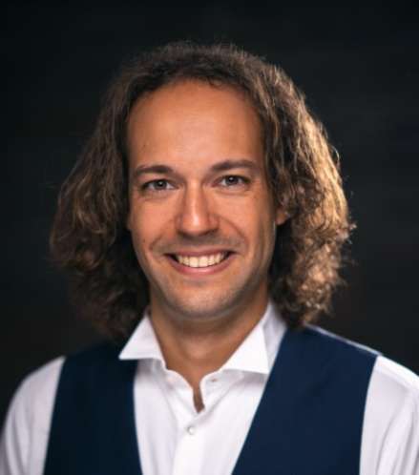
Florian Marignol BassBaritone

Thomasiusstrasse 16
D-04109 Leipzig

*1989 Toulouse (France)
+33 614399512 (Whatsapp) / +49 162 8713142

mailto:florianmarignol@murena.io
www.florianmarignol.com

Repertoire :

07.01.2023 Venosta Vogler Felix Krull (World Premiere) Excelsior Hotel Ernst - Köln
31.12.2022 Krusina Smetana Die Verkaufte Braut Oper Graz - (Jump in)
2019/2020 Engagement KTB Bern Theater :
Figaro Rossini Il Barbiere Di Siviglia KTB Bern Theater
Krusina Smetana Die Verkaufte Braut KTB Bern Theater
Sharpless Puccini Madama Butterfly KTB Bern Theater
Golaud Debussy Pélleas et Mélisande KTB Bern Theater annulé Cov19
-------------------------------------------------------------
07.2019 Schaunard Puccini La Bohème Junge Oper Schloss - Weikersheim
04.2019 Escamillo Bizet Carmen PBA Studio Lyrique - Charleroi (Belg.)
02.2019 Alberich Wagner Das Rheingold 1. Scene HFMDK Frankfurt
11.2018 Brandon Hindemith The Long Christmas Dinner HFMDK Frankfurt
11.2018 Aronte Lully Armide Projet Privé - Bonn
04.2018 Papageno Mozart Die Zauberflöte Théâtre Agen (Fr)
02.2018 Sam Bernstein Trouble in Tahiti HFMDK Frankfurt
09.2017 Gaveston Boildieu La Dame Blanche Junge Oper Rhein-Main

Educations :

Singing :
2017 - 2019 Singing Class of Thilo Dahlmann Musikhochschule - HFMDK Frankfurt Main
2012 - 2017 Singing Class of Anne Fondeville Conservatory - Toulouse

University Degrees:
2013 - 2015 MASTER Music Pedagogy and Singing University - Toulouse
2010 - 2013 BACHELOR Musicology University - Toulouse

Theory :
2016 - 2017 Music History Conservatory - Toulouse
2013 - 2016 Harmony Conservatory - Toulouse
2009 - 2016 Music Theory Conservatory - Toulouse
2009 - 2012 Choir Conservatory - Toulouse

Additionnal Skills and Activities :

Languages: French - German - English - Italian (Basic)

Competition :
08.2020 Marmande International Opera Competition (Final Round)

Scholarship :
08.2019 With " Richard Wagner Verband" from Mannheim

Others Musical Experiences:

Concerts Repertoires:
Saint-Saëns Oratorio de Noël Conductor: Ferdinand Dehner
Haydn Missa in Angustiis (Nelson) Conductor: William Hedley
Bach Magnificat Conductor: William Hedley
Bach BWV 140 Wachet auf Conductor : Georg Treuheit
Von Suppé Requiem Conductor : Georg Treuheit
Saint-Saëns Requiem Conductor: William Hedley
Dvorak Te Deum Conductor: William Hedley
Dvorak D Dur Messe Conductor: William Hedley
Carissimi Jephte - Jephte With Staging Conductor: Jean-François Gardeil
Monteverdi Vespro della Beata Vergine Les Saqueboutiers de Toulouse

Choir:
2023 Verdi Don Carlo (It) Staatsoper Berlin
Verdi Rigoletto Staatsoper Berlin
Wagner Tannhäuser Staatsoper Berlin
Strauss Der Rosenkavalier Staatsoper Berlin
Wagner Parsifal Goetheanum Dornach (CH)
2022 - 2023 Verdi Otello (Bass2) Oper Leipzig
2022 Wagner Parsifal Oper Leipzig
2012 - 2016 Donizetti Elisir d'Amore Les chants de Garonne - Agen
Lehàr Die Lustige Witwe Les chants de Garonne - Agen
Strauss Die Fledermaus Les chants de Garonne - Agen
Gardeil J-F Castafiorama (Opera Pasticcio) Les chants de Garonne - Agen
Monteverdi Vespro della Beata Vergine Les Saqueboutiers de Toulouse
2013 Ravel L'enfant et les Sortilèges Théâtre du Capitole - Toulouse
2009 - 2012 Offenbach Orphée aux Enfers Conservatory of Toulouse
Purcell King Arthur Conservatory of Toulouse

Other:
2021 Französisch Sprachcoaching für Carmen Weikersheim Festspiel

---------------------------------------------------------------------------------------------------------------------------------------------------------

Youtube Videos :

https://www.youtube.com/channel/UCAaXVAgvaE7zry04ve4ajag

